Dyslexia Handbook
2020-2021

TABLE OF CONTENTS

Millsap ISD Dyslexia Program Overview……………………………………….…… | 2
Sources of Laws and Rules for Dyslexia Identification and Instruction ……….….  Millsap ISD Board Policy ……………………………………………………….….…  Dyslexia and Related Terms …………………………………………………….……  Pathway to the Identification and Provisions of Instruction for Students with  Dyslexia (Flowchart) ………………………………………………………………….  District Dyslexia Program of Services: Screening, Evaluation, Identification and Instruction …………………………………………………………………………….. | 3  4  5  6  7
Universal Screening Flowchart.…………………………………………………….  Procedures for Evaluation …………………………………………………………  Data Gathering ………………………………….………………………….…….  Formal Evaluation …………………………………………………...……………  English Language Learners ………………………………………………………. | 9  10  10  11  12
Dyslexia Identification ………………………………………………………….….  Accommodations …………………………………………………………………...  Instructional Program ………………………………………………………….….  Student Monitoring and Dyslexia Program Exit Criteria …………………………. | 13  14  15  17
PARENTS ……………………………………………………………………………...  What Can a Parent do to Help a Child with Dyslexia? …………………………….. | 19  20
Help Build the Student’s Self-Image…………………………………………………. | 21
Dysgraphia …………………………………………………………………………….. | 22
MILLSAP ISD DYSLEXIA PROGRAM OVERVIEW

GOALS
The intent of the Millsap ISD dyslexia program is to match specialized instruction to the individual needs of students with dyslexia and related reading disorders in order to provide opportunities for these students to develop their full potential as independent readers.

Students with dyslexia or other reading disorders will:
- Be identified as early as possible in order to provide timely interventions.
- Experience success in reading, writing, and spelling.
- Gain confidence and self-esteem as they experience success.
- Apply their reading skills independently in new situations.

The program will:
- Foster in students, staff, and community an understanding of dyslexia as a learning
difference.
- Serve as a support service for students, teachers, and parents.

SERVICES

Services include but are not limited to the following:
- Provide an individualized, intensive, phonetic and multi-sensory reading, handwriting and spelling program for identified dyslexic students (based on committee recommendation).
- Conference with students, teachers and parents.
- Discuss individual student’s strengths and weaknesses with regular teachers.
- Establish with teachers and parents’ appropriate accommodations for the classroom.
- Aid in development of student organizational skills and responsibility.
- Monitor student progress and placement.
- Provide consultation and/or training on education policies, procedures, and laws and guidelines concerning the identification and placement of dyslexic students.

Under the Equal Education Opportunity Act (EEOA), Millsap ISD ensures that all students are given equal access to educational services regardless of race, color, sex, religion, or national origin. Therefore, research-based interventions are to be provided to all students experiencing difficulties in reading, including English language learners (ELL), regardless of their proficiency in English.

SOURCES OF LAWS AND RULES FOR DYSLEXIA IDENTIFICATION AND INSTRUCTION

Texas Education Code (TEC) 38.003
Texas Education Code (TEC) 28.006
Texas Education Code (TEC) 7.028 (b)
Texas Administrative Code (TAC) 74.28 (State Board of Education Rule)
The Texas Education Agency and Texas Education Code (Chapter 38) can be found at http://www.tea.state.tx.us
The Dyslexia Handbook – Revised 2018: Procedures Concerning Dyslexia and Related Disorders
https://tea.texas.gov/sites/default/files/2018-Dyslexia-Handbook_Approved_Accomodated_12_11_2018.pdf
Section 504 – Rehabilitation Act of 1973
IDEA – Individuals with Disabilities Education Act
School Boards MUST:
- Ensure that procedures for identifying a student with dyslexia or a related disorder are implemented in the district (TAC 74.28)
- Ensure that procedures for providing appropriate instructional services to the student are implemented in the district (TAC 74.28)
- Ensure that the district or school complies with all applicable requirements of state educational programs (TEC 7.028)

Districts MUST:
- Administer K-2 early screeners (TEC 28.006)
- Administer Reading Diagnosis assessments in Grades 1,2, 7 (TEC 28.006)
- Provide early identification, intervention, and support (TEC 28.006)
- Apply results of early assessment instruments to instruction and report to the Commissioners of Education (TEC 28.006)
- Implement procedures for students with dyslexia and related disorders according to State Board of Education strategies (i.e., Dyslexia Handbook) (TAC 74.28)
- Provide training of educators about dyslexia (TEC 28.006)
- Ensure the procedures for identification and instruction are in place (TAC 74.28)
- Test for dyslexia at appropriate times (TEC 38.003)
- Meet the requirements of Section 504 when assessment for dyslexia is recommended (Dyslexia Handbook)
- Provide treatment (instruction) for students with dyslexia (TEC 38.003)
- Purchase or develop their own programs that include descriptors listed in the state dyslexia handbook (TAC 74.28)
- Notify parents in writing before an assessment or identification procedures are used with an individual student (TAC 74.28)
- Inform parents of all services and options available to students eligible under the Rehabilitation Act of 1973, Section 504 (TAC 74.28)
- Provide student with services of a teacher trained in dyslexia (TAC 74.28)
- Provide a parent education program (TAC 74.28)
DYSLEXIA AND RELATED TERMS

Definition of Terms

The student who struggles with reading, writing, and/or spelling often puzzles teachers and parents. The student displays average ability to learn and receive the same classroom instruction that benefits most children; however, the student continues to struggle with some or all of the many facets of reading, writing, and/or spelling. This student may be a student with dyslexia.

As defined in TEC 38.003:
- Dyslexia means a disorder of constitutional origin manifested by a difficulty in learning to read, write, or spell, despite conventional instruction, adequate intelligence, and socio-cultural opportunity.
- Related disorders include disorders similar to or related to dyslexia such as developmental auditory imperceptions, dysphasia, specific developmental dyslexia, developmental dysgraphia, and developmental spelling disability.

The current definition from the International Dyslexia Association states:
Dyslexia is a specific learning disability that is neurological in origin. It is characterized by difficulties with accurate and/or fluent word recognition and by poor spelling and decoding abilities. These difficulties usually result from a deficit in the phonological component of language that is often unexpected in relation to other cognitive abilities and the provision of effective classroom instruction. Secondary consequences may include problems in reading comprehension and reduced reading experience that can impede growth of vocabulary and background knowledge. (Adopted by the International Dyslexia Association Board of Directors, November 12, 2002).

Characteristics of Dyslexia:
The following difficulties may be associated with dyslexia if they are unexpected for the individual’s age, educational level, or cognitive abilities:

Primary Reading/Spelling Characteristics of Dyslexia:
- Difficulty reading words in isolation
- Difficulty accurately decoding unfamiliar words
- Difficulty with oral reading (slow, inaccurate, or labored)
- Difficulty spelling

The reading/spelling characteristics are most often associated with the following:
- Segmenting, blending, and manipulating sounds in words (phonemic awareness)
- Learning the names of letters and their associated sounds
- Holding information about sounds and words in memory (phonological memory)
- Rapid recalling the name of familiar objects, colors, or letters of the alphabet (rapid naming)

Consequences of dyslexia may also include the following:
- Variable difficulty with aspects of reading comprehension
- Variable difficulty with aspects of written language
- Limited vocabulary growth due to reduced reading experiences

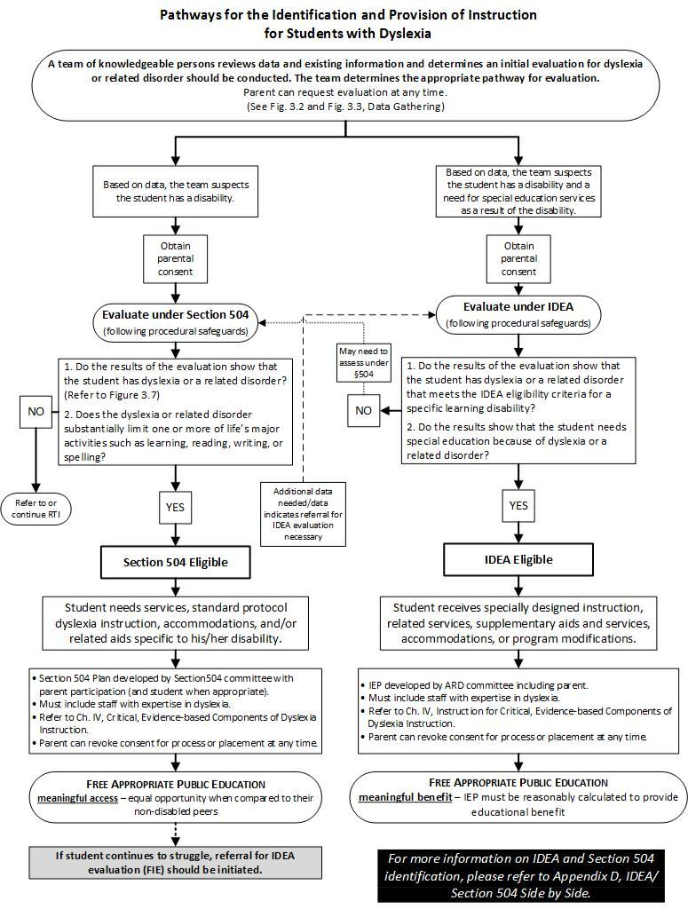

Dyslexia Handbook 2018, pg. 35
DISTRICT DYSLEXIA PROGRAM OF SERVICES: SCREENING, EVALUATION, IDENTIFICATION, AND INSTRUCTION

Early Screening

Screening is defined as a universal measure administered to all students by qualified personnel to determine which students are at risk for dyslexia or reading difficulties and/or a related disorder from The Dyslexia Handbook, pg. 9

In 2017, the 85th Texas Legislature passed House Bill (HB) 1886, amending Texas Education Code (TEC)38.003, Screening and Treatment for Dyslexia, to require that all kindergarten and first-grade public school students be screened for dyslexia and related disorders. Additionally, the law requires that all students beyond first grade be screened or tested as appropriate.” The Dyslexia Handbook, pg.9.

A related state law adds an additional layer to screening requirements for public schools in Texas. Texas Education Code 28.006, Reading Diagnosis, requires each school district to administer to students in kindergarten, first grade, and second grade a reading instrument to diagnose student reading development and comprehension. This law also requires school districts to administer a reading instrument at the beginning of seventh grade to students who did not demonstrate reading proficiency on the sixth-grade state reading assessment. The Dyslexia Handbook, pg.9.

These assessments can be from those on the Commissioners List of assessments, or one that a district level committee adopts. School districts must notify those required by the SBOE, district board of trustees, TEA, and parents and must provide an accelerated reading instruction program. The Dyslexia Handbook, pg.9.

Timeline for Early Screening

TEC 38.003 mandates that kindergarten students be screened at the end of the school year. The SBOE through approval of the rule which requires adherence to the state Dyslexia Handbook (TAC 74.28) has determined that students in first grade must be screened no later than the middle of the year. Grade 1 screening must conclude no later than January 31 of each year.

At the time of this update, there were no grade level appropriate screening instruments for dysgraphia and the other related disorders. Each district may have additional policies in place regarding screening and evaluating students for dyslexia and related disorders.

Screeners must address the following skills: (The Dyslexia Handbook, pg.12) and be administered by
- An individual certified/licensed in dyslexia, or
- A classroom teacher who holds a valid certification for Kindergarten and Grade 1

Criteria for English and Spanish Screeners
Kindergarten | First Grade
- Phonological Awareness  - Phonemic Awareness  - Sound-Symbol Recognition  - Letter Knowledge  - Decoding Skills  - Spelling  - Listening Comprehension | - Phonological Awareness  - Phonemic Awareness  - Sound-Symbol Recognition  - Letter Knowledge  - Decoding Skills  - Spelling  - Reading Rate  - Reading Accuracy  - Listening Comprehension

Administrators of the screener should also observe and document the following student behavior during the administration:

Student Behaviors Observed During Screening
- Lack of automaticity
- Difficulty sounding out words left to right
- Guessing
- Self-correcting
- Inability to focus on reading
- Avoidance behavior

Interpretation of Data

A qualified team is required to review all data to make informed decisions regarding whether a student exhibits characteristics of dyslexia and determine a plan for accelerated instruction. The team must consist of individuals who-

- have knowledge of the student;
- are appropriately trained in the administration of the screening tool;
- are trained to interpret the quantitative and qualitative results from the screening process; and
- recognize characteristics of dyslexia.

The team may consist of the student’s classroom teacher, the dyslexia specialist, the individual who administered the screener, a representative of the LPAC (as appropriate), and an administrator. If the process of identification is initiated under IDEA, the team must also include the parent and all IDEA procedures must be followed.

The Universal Screening and Data Review for Reading Risk flowchart that follows provides information regarding the decisions schools will make for each student as the school reviews screening results.

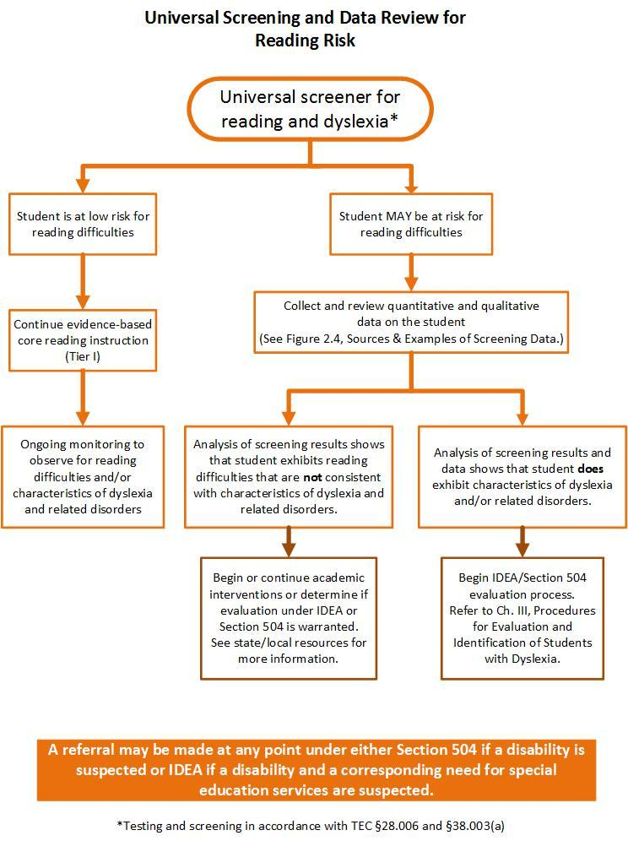

Dyslexia Handbook 2018, pg.17

Multi-tiered System of Support (MTSS)

Millsap ISD also uses a multi-tiered systems of support (MTSS) that integrates assessment and intervention within a multi‐level prevention system to maximize student achievement and reduce behavior problems. With MTSS/RTI, school staff use data to identify students at risk for poor learning outcomes, monitor student progress, provide evidence‐based interventions and adjust the intensity and nature of those interventions depending on a student’s responsiveness, and identify students with learning disabilities or other disabilities. The four essential components of an MTSS/RTI framework are screening, progress monitoring, multi-level or multi-tier prevention system, and data-based decision making.

Procedures for Evaluations

Students enrolling in Millsap ISD shall be assessed for dyslexia and related disorders at appropriate times (TEC §38.003(a)). The appropriate time depends upon multiple factors including the student’s reading performance, reading difficulties, poor response to supplemental, scientifically based reading instruction, teachers’ input, and parents’ or guardians’ input. At any time (from kindergarten through grade 12) if a student continues to struggle with one or more components of reading, Millsap ISD will collect additional information about the student.

Data Gathering

Information will be used to evaluate the student’s academic progress and determine what actions are needed to ensure the student’s improved academic performance. This information should include data that demonstrates the student was provided appropriate instruction and data-based documentation of repeated assessments of achievement at reasonable intervals (progress monitoring), reflecting formal assessment of student progress during instruction. Additional information to be considered includes the results from some or all of the following:

- Vision and Hearing screening
- Teacher reports of classroom concerns
- Classroom reading assessments
- Accommodations or interventions provided
- Academic progress reports (report cards) (all years available)
- Gifted/Talented assessments
- Samples of schoolwork
- Parent conference notes
- Testing for limited English proficiency (all years available)
- Speech and language screening through a referral process (English and native language, if possible)
- The K-2 reading instrument as required in TEC §28.006 (English and native language, if possible)
- 7th-grade reading instrument results as required in TEC§28.006
- State student assessment program as described in TEC §39.002
- Observations of instruction provided to the student
- Full Individual Evaluation (FIE)
- Outside evaluations
- School attendance (all years available)
- Curriculum-based assessment measures
- Instructional strategies provided and student’s response to the instruction
- Universal screening

Data that supports that the student received conventional (appropriate) instruction and that the difficulties are not primarily the result of sociocultural factors which include language differences, irregular attendance, or lack of experiential background.

Among the actions that Millsap ISD has available for the student is a recommendation that the student be assessed for dyslexia through §504 or IDEA. Millsap ISD recommends assessment for dyslexia if the student demonstrates the following:
- Poor performance in one or more areas of reading and/or the related area of spelling that is unexpected for the student’s age/grade
- Characteristics and risk factors of dyslexia

Formal Evaluation

In compliance with §504 and IDEA 2004, test instruments, and other evaluation materials must meet the following criteria:
- Be validated for the specific purpose for which the tests, assessments, and other evaluation materials are used
- Include material tailored to assess specific areas of educational need and not merely materials that are designed to provide a single general intelligence quotient
- Be selected and administered so as to ensure that, when a test is given to a student with impaired sensory, manual, or speaking skills, the test results accurately reflect the student’s aptitude or achievement level, or whatever other factor the test purports to measure, rather than reflecting the student’s impaired sensory, manual, or speaking skills
- Be selected and administered in a manner that is not racially or culturally discriminatory
- Include multiple measures of a student’s reading abilities such as informal assessment information (e.g., anecdotal records, district universal screenings, progress monitoring data, criterion referenced assessments, results of informal reading inventories, classroom observations)
- Be administered by trained personnel and in conformance with the instructions provided by the producer of the evaluation materials
- Be used for the purpose for which the assessment or measures are valid or reliable
- Be provided and administered in the student’s native language or other mode of communication and in the form most likely to yield accurate information regarding what the child can do academically, developmentally, and functionally, unless it is clearly not feasible to provide or administer

Domains to Assess

Millsap ISD administers measures that are related to the student’s educational needs. Depending upon the student’s age and stage of reading development, the following are the areas related to reading that should be assessed:

Academic Skills
• Letter knowledge (name and associated sound)
• Reading words in isolation
Decoding unfamiliar words accurately
• Reading fluency (both rate and accuracy are measured)
• Reading comprehension
• Spelling

Cognitive processes that underlie the reading difficulties
• Phonological/phonemic awareness (Difficulties in phonological and phonemic awareness are typically seen in students with dyslexia and impact a student’s ability to learn letters and the sounds associated with letters and letter combinations, learn the alphabetic principle, use the sounds of the letters and letter combinations to decode words and to accurately spell.)
• Rapid naming (Difficulties in rapid naming may or may not be weak, but if deficient, will impact a student’s ability to automatically name letters and read words and to read connected text at an appropriate rate.)
• Orthographic processing (Memory for letter patterns, letter sequences, and the letters in whole words may be selectively impaired or may coexist with phonological processing weaknesses.)
• Various language processes (Language processes such as morpheme and syntax awareness, memory and retrieval of verbal labels, and the ability to formulate ideas into grammatical sentences, may also be factors affecting reading.)

Based on the student’s academic difficulties and characteristics, additional areas that may be assessed include the following:
- Vocabulary
- Listening comprehension
- Verbal expression
- Written expression
- Handwriting
- Memory for letter or symbol sequences (Orthographic processing)
- Mathematical/calculation reasoning
- Phonological memory
- Verbal working memory
- Processing speed

English Language Learners: This refers to students served in Bilingual and ESL programs as well as students designated Limited English Proficient (LEP) whose parents have denied services.

Much diversity exists among English Language Learners (ELLs). The identification and service delivery process for dyslexia must be in step with the student’s linguistic environment and educational background. Involvement of the Language Proficiency Assessment Committee (LPAC) in the decision making process is required.

Additional data to be gathered when assessing English Language Learners:
- Language Proficiency Assessment Committee (LPAC) documentation which includes the following:
  - Home language survey
  - Assessment related to identification for limited English proficiency (oral language proficiency tests and norm-referenced tests)
  - State student assessment data results when available
  - Texas English Language Proficiency system (TELPAS) information (Reading Proficiency Test in English (RPTE))
  - Type of language programming provided and language of instruction
  - Linguistic environment and second-language acquisition development
  - Previous schooling in and outside of the United States

Additional assessment when assessing English Language Learners:

- Comprehensive oral language proficiency testing should be completed for a dyslexia evaluation due to the importance of the information for consideration in relation to academic challenges, planning the assessment, and interpreting assessment results.

Interpretation

Test results of English Language Learners (ELL) will be interpreted in light of the student’s: language development (in both English and the student’s native language, educational history, linguistic background, socioeconomic issues, nature of the writing system and any other pertinent factors that affect learning.

Dyslexia Identification

Questions to Determine the Identification of Dyslexia
Figure 3.7. from the Dyslexia Handbook 2018 Update: Procedures Concerning Dyslexia and Related Disorders pg. 32
- Does the data show the following characteristics of dyslexia?
Difficulty with accurate and/or fluent word reading
Poor spelling skills
Poor decoding ability
- Do these difficulties (typically) result from a deficit in the phonological component of language? (Please be mindful that average phonological scores alone do not rule out dyslexia.)
- Are these difficulties unexpected for the student’s age in relation to the student’s other cognitive abilities and provision of effective classroom instruction?

The identification of dyslexia is made by a §504 committee or, in the case of a special education referral, the admission, review, and dismissal (ARD) committee. In order to make an informed determination, either committee must include members who are knowledgeable about:

- The student being assessed
- The reading process
- Dyslexia and related disorders
- Dyslexia instruction
- District or charter school, state, and federal guidelines for assessment
- The assessments used
- The meaning of the collected data

The (§504 or ARD) committee will review all accumulated data to determine whether the student demonstrates a pattern of evidence for dyslexia. This data will include the following:
- The observations of the teacher, district or charter school staff, and/or parent/guardian
- Data gathered from the classroom (including student work and the results of classroom measures) and information found in the student’s cumulative folder (including the developmental and academic history of the student)

- Data-based documentation of student progress during instruction/intervention
- The results of administered assessments
- Language Assessment Proficiency Committee (LPAC) documentation, when applicable
- All other accumulated data regarding the development of the student’s learning and his/her educational needs

Assessment under Special Education

At any time during the assessment for dyslexia, identification process, or instruction related to dyslexia, students may be referred for evaluation for special education. At times, students will display additional factors/areas complicating their dyslexia that requires more support than what is available through dyslexia instruction. At other times, students with severe dyslexia or related disorders will be unable to make adequate academic progress within any of the programs for dyslexia or related disorders. In such cases, a referral to special education for evaluation and possible identification as a child with a disability within the Individuals with Disabilities Improvement Act of 2004 (IDEA) will be made as needed. Students with additional factors that complicate their dyslexia may require additional support or referral to special education.

Assessment of Students Identified Outside the District

Students identified as having dyslexia or related disorders from an outside source will be evaluated for eligibility in the district’s program. Millsap ISD may choose to accept the outside assessment, or may re-assess the student. In either situation, the committee (§504 or ARD) will determine the identification status of a student enrolled in Millsap ISD, and the placement of the student in the dyslexia program(s).

ACCOMMODATIONS
Millsap utilizes a team with members that have a knowledge of student, dyslexia, and reading to determine what accommodations from the state approved list a student will receive in the classroom or on State Assessments. The effectiveness of the accommodations will be monitored and will have to be used routinely and effectively in the classroom to be used on the state assessment. The State Accommodations list can be found at the TEA website:
https://tea.texas.gov/student-testing-and-accountability/testing/2019-accommodation-resources

INSTRUCTIONAL PROGRAM

Once the identification of dyslexia or a related disorder has been made, the school district must provide an appropriate instructional “evidence based” program for the student so identified. This instructional program should be offered in a small class setting on the identified student’s campus, and be delivered by an appropriately trained instructor and be implemented with fidelity. The major instructional strategies should utilize individualized, intensive, multi-sensory methods, and contain reading, writing and spelling components that include the following descriptors as appropriate, covering the critical, evidence based components of dyslexia instruction found in the Dyslexia Handbook:

- Phonological awareness— “Phonological awareness is the understanding of the internal sound structure of words. A phoneme is the smallest unit of sound in a given language that can be recognized as being distinct from other sounds. An important aspect of phonological awareness is the ability to segment spoken words into their component phonemes [phonemic awareness].” (Birsh, 2018, p. 26).
- Sound-symbol association—Sound-symbol association is the knowledge of the various speech sounds in any language to the corresponding letter or letter combinations that represent those speech sounds. The mastery of sound-symbol association (alphabetic principle) is the foundation for the ability to read (decode) and spell (encode) (Birsh, 2018, p. 26). “Explicit phonics refers to an organized program in which these sound symbol correspondences are taught systematically” (Berninger & Wolf, 2009, p. 53).
- Syllabication— “A syllable is a unit of oral or written language with one vowel sound. Instruction must include the six basic types of syllables in the English language; closed, open, vowel-consonant, r-controlled, vowel pair (or vowel team), and final stable syllable. Syllable division rules must be directly taught in relation to the word structure” (Birsh, 2018, p. 26).
- Orthography—Orthography is the written spelling patterns and rules in a given language. Students must be taught the regularity and irregularity of the orthographic patterns of a language in an explicit and systematic manner. The instruction should be integrated with phonology and sound symbol knowledge.
- Morphology— “Morphology is the study of how morphemes are combined to form words. A morpheme is the smallest unit of meaning in the language” (Birsh, 2018, p. 26).
- Syntax— “Syntax is the set of principles that dictate sequence and function of words in a sentence in order to convey meaning. This includes grammar, sentence variation, and the mechanics of language” (Birsh, 2018, p. 26).
- Reading comprehension—Reading comprehension is the process of extracting and constructing meaning through the interaction of the reader with the text to be comprehended and the specific purpose for reading. The reader’s skill in reading comprehension depends upon the development of accurate and fluent word recognition, oral language development (especially vocabulary and listening comprehension), background knowledge, use of appropriate strategies to enhance comprehension and repair it if it breaks down, and the reader’s interest in what he or she is reading and motivation to comprehend its meaning (Birsh, 2018, p.14; Snow, 2002).
- Reading Fluency- “Reading fluency is the ability to read text with sufficient speed and accuracy to support comprehension” (Moats & Dakin, 2008, p. 52). Fluency also includes prosody. Teachers can help promote fluency with several interventions that have proven successful in helping students with fluency (e.g., repeated readings, word lists, and choral reading of passages) (Henry, 2010, p. 104).

Delivery of dyslexia intervention in the above mentioned content must be delivered with research based practices including all of the following:

- Simultaneous, multisensory (VAKT)— “Teaching is done using all learning pathways in the brain (visual, auditory, kinesthetic, tactile) simultaneously in order to enhance memory and learning” (Birsh, 2018, p. 26). “Children are actively engaged in learning language concepts and other information, often by using their hands, arms, mouths, eyes, and whole bodies while learning” (Moats & Dakin, 2008, p. 58).

- Systematic and cumulative— “Multisensory language instruction requires that the organization of material follow order of the language. The sequence must begin with the easiest concepts and most basic elements and progress methodically to more difficult material. Each step must also be based on [elements] already learned. Concepts taught must be systematically reviewed to strengthen memory” (Birsh, 2018, p. 26).

- Explicit instruction— “Explicit instruction is explained and demonstrated by the teacher one language and print concept at a time, rather than left to discovery through incidental encounters with information. Poor readers do not learn that print represents speech simply from exposure to books or print” (Moats & Dakin, 2008, p. 58). Explicit Instruction is “an approach that involves direct instruction: The teacher demonstrates the task and provides guided practice with immediate corrective feedback before the student attempts the task independently” (Mather & Wendling, 2012, p. 326).
- Diagnostic teaching to automaticity— “The teacher must be adept at prescriptive or individualized teaching. The teaching plan is based on careful and [continual] assessment of the individual’s needs. The content presented must be mastered to the degree of automaticity” (Birsh, 2018, p. 27). “This teacher knowledge is essential for guiding the content and emphasis of instruction for the individual student” (Moats & Dakin, 2008, p. 58). “When a reading skill becomes automatic (direct access without conscious awareness), it is performed quickly in an efficient manner” (Berninger & Wolf, 2009, p. 70).
- Synthetic instruction— “Synthetic instruction presents the parts of the language and then teaches how the parts work together to form a whole” (Birsh, 2018, p. 27).
- Analytic instruction- “Analytic instruction presents the whole and teaches how this can be broken into its component parts (Birsh, 2018, p. 27)

Student Monitoring and Dyslexia Program Exit Criteria

Upon successful completion of Millsap ISDs program(s), as measured by program mastery checks (assessments) completed at regular intervals, students will be exited from the district dyslexia program(s). Additional criteria for exit may include but is not limited to: grades from progress reports or report cards, state assessment data, benchmarks, progress monitoring data, teacher and/or parent observations/checklists, and individual dyslexia program requirements.

Students that have completed the Millsap ISD dyslexia program will receive regular monitoring during the first three years as follows:

Time After Exit | Monitoring Interval
1st Year | Once per grading period
2nd Year | Once a semester
3rd Year | Annually

Note: The §504 committee will meet annually for all students being served in the dyslexia program, as well as monitored students.

Monitoring may include, but is not limited to the collection/evaluation of:
- Progress reports and report cards
- State assessment data
- Teacher reports/checklists
- Parent reports/checklists
- Counselor reports
- Other program reports
- Additional assessment data

Students qualifying for dyslexia services that are identified as §504 or special education will follow monitoring/re-evaluation requirements outlined in federal law.

No one factor is sufficient to warrant exiting a student from direct dyslexia services. Dismissal is determined by the §504 committee, or ARD committee. The committee considers the following factors when recommending exiting or reduction of dyslexic services:

- Completion of the district dyslexia program
- The reevaluation and/or post-testing of student shows student growth to be closer to grade level proficiency standards
(NOTE: Reevaluation does not mean reassessing to establish the identification of dyslexia, but rather viewing data that supports student progress, and achievement.)
- The student demonstrates self-monitoring/self-correction behaviors as evidenced through informal observation by teacher and/or dyslexia teacher
- The student passed the reading portion of the state assessment (NOTE: passing the reading portion of the state assessment is never the sole source for exiting dyslexia services);
- Committee recommendation
- Parent request in writing that the student exit the program

If a student has shown substantial progress and the §504 committee, or ARD committee determines the student is ready to be dismissed completely from the program, the committee may recommend monitoring services instead of direct services.

Parents

WHAT CAN A PARENT DO TO HELP A CHILD WITH DYSLEXIA?

Help your child understand the nature of his difficulty.
- Read books or view videos about dyslexia.
- Emphasize the child’s abilities instead of “disabilities.”

Help other members of the family.
- They need to recognize and understand the learning disabled child. The child with dyslexia may sometimes have difficulty relating an event in proper sequence. Family members often need to ask “who, what, where, and when” questions to get the necessary information.

Help your child locate and develop other talents:
- Sports, art, music, mechanics, hobbies, etc.

Help improve his self-image by giving your child tasks he can master.
- Give the child chores to do. Boys and girls should do chores such as setting the table for supper, clearing the dishes, and making the beds.
- Make short lists of tasks to help him remember. A list is impersonal and reduces irritations. The child will gain satisfaction as he checks off tasks completed.
- Often children do not process multiple requests quickly or accurately. State your ideas in simple, clear, one-concept commands and ask the child to repeat what was said. Speaking at a slower rate of speed to the child is often helpful.

Structure the child’s life at home.
- Stick to a regular routine for meals, play, TV, chores, bedtime, etc.
- Keep belongings in the same place. Help the child remember where to put them.
- Keep instructions simple – one at a time.
- Break tasks into small parts or steps and give him one step at a time.
- Relieve stress in weak areas.
- Guard against negative remarks, especially those referring to laziness or lack of effort.
- Avoid threats of punishment for such things as low grades, their need for repetition of directions, ineptness at simple tasks, etc.
- Set standards, goals and expectations of achievement within reach of your child’s abilities.

How can parents build self-esteem?
- Praise your child often and sincerely.
- Don’t constantly nag or criticize.
- Catch your child doing well.
- Give your child opportunities to succeed.
- Tell your child you believe in him or her.
- Give your child lots of hugs and kisses.
- Praise efforts that are working towards a goal.
- Don’t compare your child with anyone else.
- Look for ways to make your child feel capable.
- Encourage your child to make age appropriate decisions.
- Give your child a chance to solve problems before jumping in.
HELP BUILD THE STUDENT’S SELF-IMAGE

Stress verbal participation.
- Reduce reading aloud and grade oral work in addition to written.
- Decrease the amount of written work in favor of oral.
- Call on student to read aloud only when he/she volunteers.
- Ask student to listen to information and report orally on a specific topic.

Make directions simple and brief.
- Refrain from long verbal explanations.
- Question student briefly to make sure he understands. Ask student to give you an example to confirm his understanding.
- Give examples, demonstrate.
- Encourage student to ask questions and treat each question patiently.

Break assignments into steps. Model assignments and talk about what you are doing while you model.
- Have someone write student’s assignments.
- Help student organize and get started.
- Help student schedule long assignments.

Make special accommodations when needed.
- Provide memory aids.
- Provide visual reminders or examples.
- Allow student to tape record lectures and test reviews.
- Provide audio books of content area textbooks.
- Allow sub-vocalizing. Repeat sounds while spelling.

What strengths are we likely to see in individuals with dyslexia?
- Highly creative
- Links previously unrelated ideas, processes
- Finds new ways to do old things
- Problem solver/Inventor/Builder
- Diplomat
- Good sense of humor
- Likes and enjoys helping people
- May anticipate people’s emotions
- Excels at individual sports
- Works better alone than with team
- Understands animals, plants, living things
- Mechanically Inclined-Wants to know how things work
- Likes to repair or make things better
- Enjoys working with hands, Likes building things
- Scientific thinker
- Very curious and observant

Dysgraphia

DYSGRAPHIA

Texas state law requires districts and charter schools to identify students who have dyslexia and related disorders. Texas Education Code §38.003 identifies the following examples of related disorders: developmental auditory imperceptions, dysphasia, specific developmental dyslexia, developmental dysgraphia, and developmental spelling disability. Recent research in the field of dysgraphia has prompted the addition of the following guidance regarding the evaluation, identification, and provision of services for students with dysgraphia.

Definition and Characteristics of Dysgraphia

Difficulty with handwriting frequently occurs in children with dyslexia. When Texas passed dyslexia legislation, the co-existence of poor handwriting with dyslexia was one reason why dysgraphia was called a related disorder. Subsequently, dyslexia and dysgraphia have been found to have diverse co-morbidities, including phonological awareness (Döhla and Heim, 2016). However, dyslexia and dysgraphia are now recognized to be distinct disorders that can exist concurrently or separately. They have different brain mechanisms and identifiable characteristics.

Dysgraphia is related to dyslexia as both are language-based disorders. In dyslexia, the impairment is with word-level skills (decoding, word identification, spelling). Dysgraphia is a written language disorder in serial production of strokes to form a handwritten letter. This involves not only motor skills but also language skills—finding, retrieving and producing letters, which is a subword-level language skill. The impaired handwriting may interfere with spelling and/or composing, but individuals with only dysgraphia do not have difficulty with reading (Berninger, Richards, & Abbott, 2015).

A review of recent evidence indicates that dysgraphia is best defined as a neurodevelopmental disorder manifested by illegible and/or inefficient handwriting due to difficulty with letter formation. This difficulty is the result of deficits in graphomotor function (hand movements used for writing) and/or storing and retrieving orthographic codes (letter forms) (Berninger, 2015). Secondary consequences may include problems with spelling and written expression. The difficulty is not solely due to lack of instruction and is not associated with other developmental or neurological conditions that involve motor impairment.

The characteristics of dysgraphia include the following:
- Variably shaped and poorly formed letters
- Excessive erasures and cross-outs
- Poor spacing between letters and words
- Letter and number reversals beyond early stages of writing
- Awkward, inconsistent pencil grip
- Heavy pressure and hand fatigue
- Slow writing and copying with legible or illegible handwriting (Andrews & Lombardino, 2014)

Additional consequences of dysgraphia may also include:
- Difficulty with unedited written spelling
- Low volume of written output as well as problems with other aspects of written expression
Dysgraphia is not:
- Evidence of a damaged motor nervous system
- Part of a developmental disability that has fine motor deficits (e.g., intellectual disability, autism, cerebral palsy)
- Secondary to a medical condition (e.g., meningitis, significant head trauma, brain trauma)
- Association with generalized developmental motor or coordination difficulties (Developmental Coordination Disorder)
- Impaired spelling or written expression with typical handwriting (legibility and rate) (Berninger, 2004)

Dysgraphia can be due to:
- Impaired feedback the brain is receiving from the fingers
- Weaknesses using visual processing to coordinate hand movement and organize the use of space
- Problems with motor planning and sequencing
- Difficulty with storage and retrieval of letter forms (Levine, 1999)

Despite the widespread beliefs that handwriting is purely a motor skill or that only multisensory methods are needed to teach handwriting, multiple language processes are also involved in handwriting. Handwriting draws on language by hand (letter production), language by ear (listening to letter names when writing dictated letters), language by mouth (saying letter names), and language by eye (viewing the letters to be copied or reviewing for accuracy the letters that are produced from memory) (Berninger & Wolf, 2016).

Dysgraphia

Students enrolling in Millsap ISD shall be assessed for dyslexia and related disorders at appropriate times (TEC §38.003(a)). When dysgraphia is suspected, the Millsap ISD campus dyslexia therapist will administer the District Dysgraphia Screener. If the screener provides an indication of dysgraphia and the student has received effective handwriting instruction, then the student should be referred for a formal dysgraphia evaluation.

Campuses in Millsap ISD should recommend screening for dysgraphia if the student demonstrates the following:
- Impaired or illegible handwriting that is unexpected for the student’s age/grade
- Impaired handwriting that interferes with spelling, written expression, or both that is unexpected for the student’s age/grade

Process for Evaluation
The same processes for evaluation of dyslexia apply to dysgraphia. Students may be identified through Section §504 or IDEA, and the same guidelines discussed previously must be applied.

Documentation of the following characteristics of dysgraphia should be collected during the data gathering stage of evaluation:

- Slow or labored written work
- Poor formation of letters
- Improper letter slant
- Poor pencil grip
- Inadequate pressure during handwriting
- Excessive erasures
- Poor spacing between words
- Poor spacing inside words
- Inability to recall accurate orthographic patterns for words
- “b” and “d” reversals beyond developmentally appropriate time
- Inability to copy words accurately
- Inability of student to read what was previously written
- Overuse of short familiar words such as “big”
- Avoidance of written tasks
- Difficulty with visual-motor integrated sports or activities

n compliance with IDEA and Section §504 , Millsap ISD administers test instruments and other evaluation materials that assess the following domains:

Academic Skills
- Letter formation
- Handwriting
- Word/sentence dictation (timed and untimed)
- Copying of text
- Written expression
- Written Fluency (both accuracy and fluency)

Cognitive Processes
- Memory for letter or symbol sequences (orthographic processing)

Based on the student’s academic difficulties and characteristics, additional areas that may be assessed include the following:

- Phonological awareness
- Phonological memory
- Working memory
- Letter retrieval
- Letter matching
Review and Interpretation of Data
In order to make an informed determination, either committee must include members who are knowledgeable about:
- The student being assessed
- The handwriting process
- Dysgraphia and related disorders
- Dysgraphia instruction
- District, state, and federal guidelines for evaluation

The (§504 or ARD) committee will review all accumulated data to determine whether the student demonstrates a pattern of evidence for dysgraphia. This data will include the following:
- The observations of the teacher, district or charter school staff, and/or parent/guardian
- Data gathered from the classroom (including student work and the results of classroom measures) and information found in the student’s cumulative folder (including the developmental and academic history of the student)
- Data-based documentation of student progress during instruction/intervention
- The results of administered assessments
- Language Assessment Proficiency Committee (LPAC) documentation, when applicable
- All other accumulated data regarding the development of the student’s learning and his/her educational needs

Questions to Determine the Identification of Dysgraphia
- Does the data show a pattern of low writing and spelling ability that is unexpected for the student in relation to the student’s other cognitive abilities and provision of effective classroom instruction? It is important to remember that a student cannot be identified with dysgraphia if he/she has not been taught handwriting with fidelity.
- Does the pattern indicate the student has dysgraphia?
- Does the student meet eligibility as a student with a disability under Section 504 or IDEA?

Instruction for Students with Dysgraphia

Between 10% and 30% of student struggle with handwriting. The following are research-based elements of effective handwriting instruction, in both manuscript and cursive handwriting:

- Show students how to hold a pencil.
- Model efficient and legible letter formation.
- Provide multiple opportunities for students to practice effective letter formation.
- Use scaffolds, such as letters with numbered arrows showing the order and direction of strokes.
- Have students practice writing letters from memory.
- Provide handwriting fluency practice to build students’ automaticity.
- Practice handwriting in short sessions.

Handwriting supports spelling. Orthography is the written spelling patterns and rules in a given language. Students must be taught the regularity and irregularity of the orthographic patterns of language in an explicit and systematic manner. As a result, students with dysgraphia will benefit from the following guiding principles:

- Phoneme-grapheme correspondence
- Letter order and sequence patters, or orthographic conventions
  - Syllable types
  - Orthographic rules
  - Irregular words
- Position of phoneme or grapheme in a word
- Meaning and part of speech
- Language of origin

Students with written expression difficulties because of dysgraphia would benefit from being taught explicit strategies for composing, including the writing process and genre specific forms.

The way the content is delivered should be consistent with the principles of effective intervention for student with dysgraphia include the following:
- Simultaneous, multisensory (VAKT)
- Systematic and cumulative
- Explicit instruction
- Diagnostic teaching to automaticity

Instructional Accommodations for Students with Dysgraphia
In addition to targeted instruction, accommodations provide the student with dysgraphia effective and equitable access to the general education classroom. Accommodations are not a one size fits all; rather, the impact of dyslexia on each individual determines the necessary accommodation. Listed below are examples of reasonable classroom accommodations for Millsap ISD:

- Allow more time for written tasks, including note taking, copying, and tests
- Reduced the length requirement of written assignments
- Provide copies of notes or assign a note taking buddy to assist with filling in missing information
- Allow the student to audio record important assignments and/or take oral tests
- Assist student with developing logical steps to complete a writing assignment instead of all at once
- Allow the use of technology
- Allow the student to use cursive or manuscript, whichever is most legible and efficient
- Allow the student to use graph paper for math, or to turn lines paper sideways, to help with lining up columns with numbers
- Offer an alternative to a written project such as an oral report, dramatic presentation, or visual media project

There are many technology resources to assist a student with dysgraphia. The technology Integration for Students with Dyslexia online tool (TEC §38.0031) is a resource developed to support school districts and charter schools in making instructional decisions regarding technology that benefit students with dyslexia and related disorders. For more information and to view this source, visit https://www.region10.org/programs/dyslexia/techplan/

See Millsap ISD Board Policy EHB (LEGAL) for more information.

For additional questions, please contact the following:

Dyslexia Therapist
Ms. Melisa Simmons
msimmons@millsapisd.net
940-682-3121

District Contact
Ms. Edie Martin, Assistant Superintendent
emartin@millsapisd.net
940-682-3101

